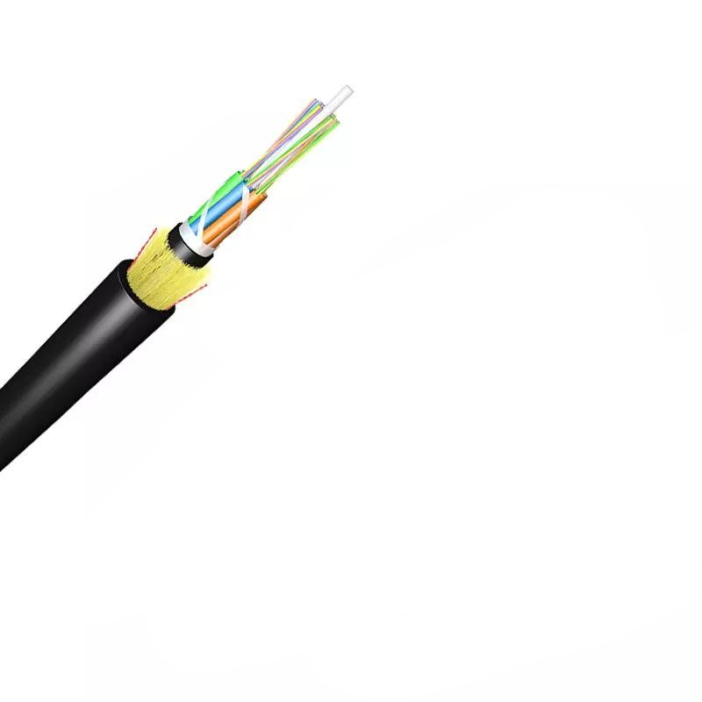
Technical Specification for ADSS Optical Cable

1. General Information
- Type: ADSS-Single Sheath
- Certifications: ISO9001
- Length per Spool: 3km or 4km (2% tolerance allowed)
- Packing: Wooden Spool (Φ1100*750mm)
- MOQ: 100km
- Delivery Time: 5-25 Days
- Port of Loading: NINGBO CHINA
- Payment Term: 30% TT as deposit, 70% Balance before shipping

2. Optical Fiber Specifications

2.1 Fiber Types
- G.652.D (single-mode)
- G.655 (single-mode)
- 50/125μm Multimode
- 62.5/125μm Multimode

2.2 Transmission Characteristics
Wavelength | Attenuation | Bandwidth
850nm | 50/125μm: ≤3.0 dB/km; 62.5/125μm: ≤3.0 dB/km | 50/125μm: ≥500 MHz·km; 62.5/125μm: ≥200 MHz·km
1300nm | 50/125μm: ≤1.0 dB/km; 62.5/125μm: ≤1.0 dB/km | 50/125μm: ≥1000 MHz·km; 62.5/125μm: ≥600 MHz·km
1310nm | G.652.D: ≤0.36 dB/km; G.655: ≤0.40 dB/km | -
1550nm | G.652.D: ≤0.22 dB/km; G.655: ≤0.23 dB/km | -

2.3 Polarization Mode Dispersion (PMD)
- Individual Fiber: G.652.D/G.655 ≤0.20 ps/√km
- Design Link Value (M=20, Q=0.01%): G.652.D/G.655 ≤0.10 ps/√km

2.4 Mode Field Diameter (MFD)
- 1310nm: G.652.D Normal (8.6±0.4μm); G.652.D Best (9.0±0.4μm); G.657.A1 (9.0±0.3μm); G.657.A2 (8.6±0.4μm)
- 1550nm: G.652.D Normal (9.8±0.5μm); G.652.D Best (10.2±0.4μm); G.657.A2 (9.6±0.5μm)

2.5 Point Discontinuity
- At 1310nm & 1550nm: ≤0.05 dB

3. Cable Structure

3.1 Core Components
- Fiber Optic: UV fiber G.652.D; @1310nm ≤0.35dB/km; @1550nm ≤0.2dB/km
- Tube Filling Compound: Water Blocking & Moisture Proof Thyrotrophic gel
- Loose Tube: 1.8-2.0mm PBT; Outer diameter options: 1.8/2.0/2.5mm (adjustable: 1.5|2.0, 1.8|2.3, 2.1|2.3mm)
- Filler: 1.8mm LDPE/PP (FRP)
- Central Strength Member: 1.8mm GFRP; Diameter options: 2.0/2.5/2.8/3.7mm (adjustable: 1.8|2.3, 2.5, 2.8, 3.7, 2.6mm); PE coated optional
- Water Blocking Layer: 0.28mm thick water blocking tape + 2 water blocking yarns
- Binder: 2 wires Polyester Yarns
- Ripcords: 2 wires
- Dielectric Strength Members: Aramid Yarns KEVLAR K49-3000D
- Inner Jacket: 0.9-1.0mm thick HDPE/MDPE
- Outer Jacket: 1.6-2.0mm thick HDPE/MDPE; Standard thickness 1.8mm (1.5-2.0mm for OEM)

3.2 Cable Dimensions & Weight
- Cable Outer Diameter: 10.7±0.5mm (adjustable: 8.0|8.5|9.0|10.5|11.0mm)
- 6 fibers: 9.5mm
- 12 fibers: 9.5mm|10mm
- 24 fibers: 12.2mm
- 48 fibers: 13.9mm
- 72 fibers: 17.1mm
- 96 fibers: 20.2mm
- Cable Weight: 85±5kg/km
- 12-core: 75kg/km
- 24-core & larger: 95kg/km

3.3 Fiber Count & Loose Tube Configuration
Fiber Count | Tube Configuration
6 | 1x6, 2x6, 4x6
8 | 6x8
12 | 4x12, 6x12, 8x12, 12x12
24 | 24x12
48/72/96/144/288 | Customizable

4. Mechanical Characteristics
- Fiber Strain: ≥1%
- Fiber Load: ≥9N
- Stress: ≥100kpsi
- Dynamic Stress Corrosion Susceptibility Factor: ≥20 (unaged & aged: 30 days @85°C, 85% R.H.)
- Coating Strip Force (Peak Value): 1.3-8.9N
- Fiber Curl: ≥4m
- Max Installation Tension: 2400N (all core configurations)
- Min Bending Radius: Without tension (10x cable diameter); Under max tension (20x cable diameter)
- Max Span: 50m/80m/100m/120m/150m (80m standard for 24F model)
- MAT (Mechanical Test): 2100N

4.1 Mechanical Tests
Test Item | Method | Acceptance Requirement
Tensile Strength | 5000N load over 50m cable | ≤0.1dB loss @1550nm; No fiber break/sheath damage
Crush Test | 3000N load over 100mm for ≥1min | ≤0.1dB loss @1550nm; No fiber break/sheath damage
Impact Test | 5 points, 5 times/point; 4.5Nm energy | ≤0.1dB loss @1550nm; No fiber break/sheath damage
Repeated Bending | 20x OD bending diameter; 250N load; 30 cycles | ≤0.1dB loss @1550nm; No fiber break/sheath damage
Torsion | 1m length; 150N load; ±90° twist; 10 cycles | ≤0.1dB loss @1550nm; No fiber break/sheath damage

5. Environmental Characteristics
- Temperature Range:
- Operation: -40°C to +70°C
- Installation: -20°C to +60°C
- Transport & Storage: -40°C to +70°C
- Weather Conditions: 25m/s wind speed + 0mm Ice Load
- Max Applied Voltage: 110kv

5.1 Environmental Tests
Test Item | Condition | Attenuation Requirement
Dry Heat Aging | 30 days @85°C | ≤0.05dB/km (@1310/1550nm)
Accelerated Aging | 30 days @85°C, 85% R.H. | ≤0.05dB/km (@1310/1550nm)
Temperature Cycling | +20→-20→+20→+40°C; 2 cycles | ≤0.05dB/km (@1310/1550nm); No fiber break/sheath damage
Water Soak | 30 days @23°C | ≤0.05dB/km (@1310/1550nm)
Water Penetration | 3m sample in 1m water for 24h | No water leakage
Compound Flow | 30cm sample @70±2°C for 24h | No compound flow
Sheath High Voltage Test | Online test with 9kV (dependent on sheath thickness) | No sheath breakdown

6. Standards Compliance
- ITU-T Rec. G.657A, G.652.D
- ISO9001
- IEC 60794
- ICEA-596
- GR-409
- YD/T 1997-2009
- EIA/TIA 598B (fiber/binder color code)

7. Marking & Color Code

7.1 Cable Marking
- Content: Cable name, N*cores, G.652D, manufacture year, length (meter)
- Interval: Every 1 meter
- Color: White
- End Sealing: Heat shrinkable end caps

7.2 Fiber Colors (12 Chromatography)
- Blue
- Orange
- Brown
- Gray
- White
- Red
- Black
- Yellow
- Violet
- Aqua
- Pink
- Green

8. OEM Customization
- Fiber count: 12/24/48/96/120/144 cores
- Structure design: 3+2+1 (12-core); 1+4+1 (24/48-core etc.)
- Central strength member: FRP/Steel Wire (1.2/1.0mm diameter)
- Outer sheath thickness: 0.8mm (smaller cores); 1.6/1.9mm (larger cores)
- Cable diameter: 9.0mm (12-core); 13mm (24-core & larger)
- Custom cable marking available
Note: Cable diameter and weight are typical values, subject to design variations. Span needs recalculation for specific regional climate conditions. Other structures and fiber counts available on request.

