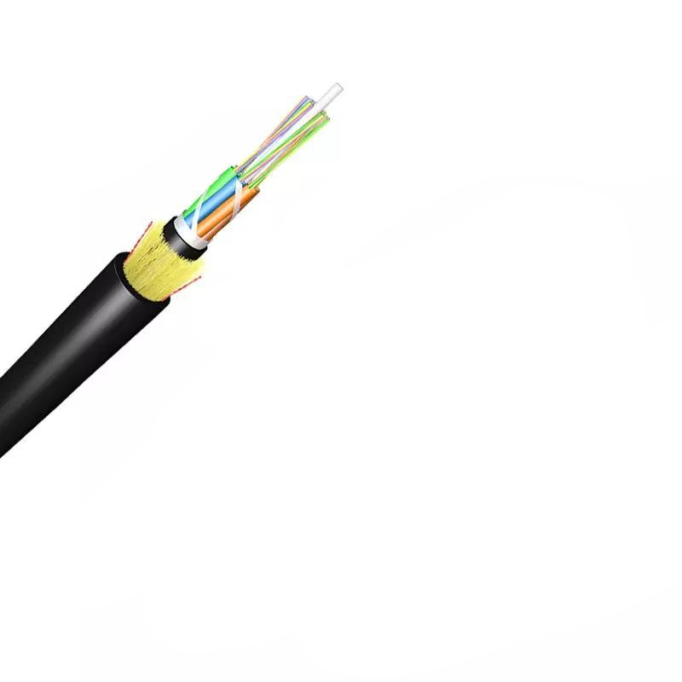
Technical Specification of ADSS Optical Fiber Cable

1. General Information
- Type: ADSS (All-Dielectric Self-Supporting) Single Jacket Optical Fiber Cable
- Certifications: ISO9001
- Length per Spool: 3km or 4km (with a tolerance of more than 2%)
- Packing: Wooden Spool (Φ1100*750mm), covered by plastic buffer sheet, sealed by strong wooden battens. At least 1m of the inside end of the cable is reserved for testing.
- MOQ: 100km
- Delivery Time: 5-25 Days
- Port of Loading: NINGBO CHINA
- Term of Payment: 30% TT as deposit, 70% Balance before shipping

2. Fiber Specifications

2.1 Fiber Types
- G.652.D
- G.655
- 50/125μm Multimode
- 62.5/125μm Multimode

2.2 Optical Characteristics
Parameter | Details
Attenuation (@850nm) | 50/125μm: ≤3.0 dB/km; 62.5/125μm: ≤3.0 dB/km
Attenuation (@1300nm) | 50/125μm: ≤1.0 dB/km; 62.5/125μm: ≤1.0 dB/km
Attenuation (@1310nm) | G.652.D: ≤0.36 dB/km; G.655: ≤0.40 dB/km
Attenuation (@1550nm) | G.652.D: ≤0.22 dB/km; G.655: ≤0.23 dB/km
Bandwidth (@850nm) | 50/125μm: ≥500 MHz·km; 62.5/125μm: ≥200 MHz·km
Bandwidth (@1300nm) | 50/125μm: ≥1000 MHz·km; 62.5/125μm: ≥600 MHz·km
Polarization Mode Dispersion (PMD) - Individual Fiber | G.652.D: ≤0.20 ps/√km; G.655: ≤0.20 ps/√km
PMD - Design Link Value (M=20, Q=0.01%) | G.652.D: ≤0.10 ps/√km; G.655: ≤0.10 ps/√km
Mode Field Diameter (@1310nm) | G.652.D Normal: 8.6±0.4μm; G.652.D Best: 9.0±0.4μm; G.657.A1: 9.0±0.3μm; G.657.A2: 8.6±0.4μm
Mode Field Diameter (@1550nm) | G.652.D Normal: 9.8±0.5μm; G.652.D Best: 10.2±0.4μm; G.657.A1: 10.2±0.4μm; G.657.A2: 9.6±0.5μm
Zero Dispersion Wavelength | 1300-1324 nm for all variants
Dispersion Coefficient (1285-1339nm) | G.652.D: ≤3.4 ps/(nm·km); G.657.A1 & A2: ≤3.4 ps/(nm·km)
Point Discontinuity (1310nm & 1550nm) | ≤0.05 dB for all fibers

2.3 Transmission Wavelength Bands
- O Band (1260-1360 nm): 237.9-220.4 THz, typically for multimode systems
- E Band (1360-1460 nm): Less commonly used due to higher attenuation
- S Band (1460-1530 nm): 205.3-195.9 THz, used in Passive Optical Networks (PON)
- C Band (1530-1565 nm): 195.9-191.6 THz, widely used for long-haul transmission (minimum attenuation)
- L Band (1565-1625 nm): 191.6-184.5 THz, for extended reach and high-capacity networks
- U Band (1625-1675 nm): 184.5-179.0 THz, primarily for network monitoring

2.4 Attenuation Coefficient at Various Wavelengths
- 1310 nm: G.652.D Normal ≤0.35 dB/km; G.652.D Best ≤0.34 dB/km; G.657.A1 & G.657.A2 ≤0.34 dB/km
- 1285-1330 nm: All fibers ≤0.37 dB/km
- 1383 nm: G.652.D Normal & Best ≤0.30 dB/km; G.657.A1 & G.657.A2 ≤0.31 dB/km
- 1490 nm: G.652.D Best ≤0.23 dB/km; G.657.A1 & G.657.A2 ≤0.23 dB/km; G.652.D Normal ≤0.24 dB/km
- 1550 nm: G.652.D Normal ≤0.22 dB/km; G.652.D Best ≤0.21 dB/km; G.657.A1 & G.657.A2 ≤0.20 dB/km
- 1525-1575 nm: G.652.D Normal ≤0.22 dB/km; G.652.D Best ≤0.21 dB/km; G.657.A1 & G.657.A2 ≤0.21 dB/km
- 1625 nm: G.652.D Normal ≤0.25 dB/km; G.652.D Best ≤0.24 dB/km; G.657.A1 & G.657.A2 ≤0.22 dB/km

2.5 Bending Loss
- 1550 nm: 10 turns (15mm radius) ≤0.25 dB; 100 turns (25mm radius) ≤0.03 dB; 1 turn (10mm radius) ≤0.75 dB; 1 turn (7.5mm radius) ≤0.2 dB; 100 turns (30mm radius) ≤0.05 dB
- 1625 nm: 10 turns (15mm radius) ≤1.0 dB; 1 turn (10mm radius) ≤1.5 dB; 1 turn (7.5mm radius) ≤0.5 dB

3. Cable Structure

3.1 Core Components
- Fiber Optic: UV fiber G.652.D; @1310nm ≤0.35dB/km; @1550nm ≤0.2dB/km
- Tube Filling Compound: Water Blocking & Moisture Proof Thyrotrophic gel
- Loose Tube: 1.8-2.0mm PBT; outer diameter options: 1.8, 2.0, 2.5mm (adjustable OEM: 1.5|2.0, 1.8|2.3, 2.1|2.3mm)
- Filler FRP: 1.8mm LDPE/PP
- Center Strength Member: 1.8mm GFRP; diameter options: 2.0, 2.5, 2.8, 3.7mm (adjustable OEM: 1.8|2.3, 1.8|2.3, 2.5, 2.8, 3.7, 2.6mm); PE coated available for specific designs
- Water Blocking Tape: 0.28mm thickness
- Binder: 2 wires Polyester Yarns
- Ripcords: 2 wires
- Dielectric Strength Members: Aramid Yarns KEVLAR K49-3000D
- Inner Jacket: 0.9-1.0mm thickness HDPE/MDPE
- Outer Jacket: 1.6-2.0mm thickness HDPE/MDPE; standard thickness 1.8mm (1.5-2.0mm for OEM)

3.2 Key Dimensions & Weight
- Cable Outer Diameter: 10.7±0.5mm (adjustable OEM: 8.0|8.5|9.0|10.5|11.0mm)
- 6 fibers: 9.5mm
- 12 fibers: 9.5mm|10mm
- 24 fibers: 12.2mm
- 48 fibers: 13.9mm
- 72 fibers: 17.1mm
- 96 fibers: 20.2mm
- Cable Weight: 85±5kg/km (typical value; varies by design)
- 12-core: 75kg/km
- 24-core and larger: 95kg/km

3.3 Fiber Count & Loose Tube Configuration
- Fiber Count Options: 6, 12, 24, 48, 72, 96, 144, 288 fibers (OEM: 12, 24, 48, 96, 120, 144 cores)
- Tubes per Fiber Count:
- 6 fibers: 1x6, 2x6, 4x6
- 8 fibers: 6x8
- 12 fibers: 4x12, 6x12, 8x12, 12x12 (OEM design for 12-core: 3+2+1)
- 24 fibers: 24x12 (OEM design for 24-core, 48-core, etc.: 1+4+1)

4. Mechanical Characteristics
- Fiber Strain: ≥1%
- Fiber Load: ≥9 N
- Stress: ≥100 kpsi
- Dynamic Stress Corrosion Susceptibility Factor: ≥20 (unaged & aged: 30 days @85°C, 85% R.H.)
- Coating Strip Force (Peak Value): 1.3-8.9 N
- Fiber Curl: ≥4 m
- Max. Installation Tension: 2400 N (for all core configurations)
- Min. Bending Radius: Without Tension: 10.0 x Cable Diameter; Under Maximum Tension: 20.0 x Cable Diameter
- MAT (Mechanical Test): Tailored to customer requirements; Max Span options: 50m, 80m, 100m, 120m, 150m (120m span for this model, MAT=3300N)

5. Environmental Characteristics
- Temperature Range:
- Operation: -40°C to +70°C
- Installation: -20°C to +60°C
- Transport & Storage: -40°C to +70°C
- Climate Conditions: 25m/s wind speed, 0mm Ice Load; no ice formation considered in design
- Dry Heat Aging (30 days @85°C): Attenuation @1310nm & 1550nm ≤0.05 dB/km
- Accelerated Aging (30 days @85°C, 85% R.H.): Attenuation @1310nm & 1550nm ≤0.05 dB/km
- Temperature Cycling: Attenuation @1310nm & 1550nm ≤0.05 dB/km
- Water Soak (30 days @23°C): Attenuation @1310nm & 1550nm ≤0.05 dB/km

6. Test Standards & Requirements

6.1 Standards Compliance
ITU-T Rec. G.657A, ISO9001, IEC 60794, ICEA-596, GR-409, YD/T 1997-2009

6.2 Mechanical & Environmental Tests
Test Item | Test Method | Acceptance Requirements
Tensile Strength (IEC 794-1-E1) | Apply 5000N load over 50m cable length | Loss change ≤0.1dB @1550nm; no fiber break, no sheath damage
Crush Test (IEC 60794-1-E3) | Apply 3000N load over 100mm cable for ≥1 minute | Loss change ≤0.1dB @1550nm; no fiber break, no sheath damage
Impact Test (IEC 60794-1-E4) | 5 impact points, 5 times per point; 4.5Nm energy; 12.5mm hammerhead radius; 2s/cycle | Loss change ≤0.1dB @1550nm; no fiber break, no sheath damage
Repeated Bending (IEC 60794-1-E6) | Bend with 20x outer diameter; 250N load; 3s/cycle; 30 cycles | Loss change ≤0.1dB @1550nm; no fiber break, no sheath damage
Torsion (IEC 60794-1-E7) | 1m length; 150N load; ±90° twist angle; 10 cycles; 1min/cycle | Loss change ≤0.1dB @1550nm; no fiber break, no sheath damage
Water Penetration (IEC 60794-1-F5B) | Submerge 3m cable in 1m water for 24 hours | No water leakage from opposite end
Temperature Cycling (IEC 60794-1-F1) | +20°C→-20°C→+20°C→+40°C; 24h/step; 2 cycles | Loss change ≤0.1dB @1550nm; no fiber break, no sheath damage
Compound Flow (IEC 60794-1-E14) | 30cm sample; 70±2°C; 24 hours | No compound flow
Sheath High Voltage Test | Online test with 9kV voltage (dependent on sheath thickness) | No sheath breakdown

7. Marking & Color Codes

7.1 Cable Marking
- Printed every 1 meter: [Cable type] N*cores G.652D [Manufacture year] XXXXm
- Marking color: White
- Occasional unclear length marking permitted if neighboring markings are clear
- Both cable ends sealed with heat shrinkable end caps to prevent water ingress
- Custom marking available per client request

7.2 Fiber & Binder Color Code (EIA/TIA 598B)
- Blue
- Orange
- Green
- Brown
- Gray
- White
- Red
- Black
- Yellow
- Violet
- Pink
- Aqua

8. Additional Specifications
- Max Applied Voltage: 110kv
- Outer Sheath Color: Black (OEM customizable)
- Customization: Other structures, fiber counts, cable diameters, and weights available per customer requirements. Span recalculated based on installation area's climate conditions.

