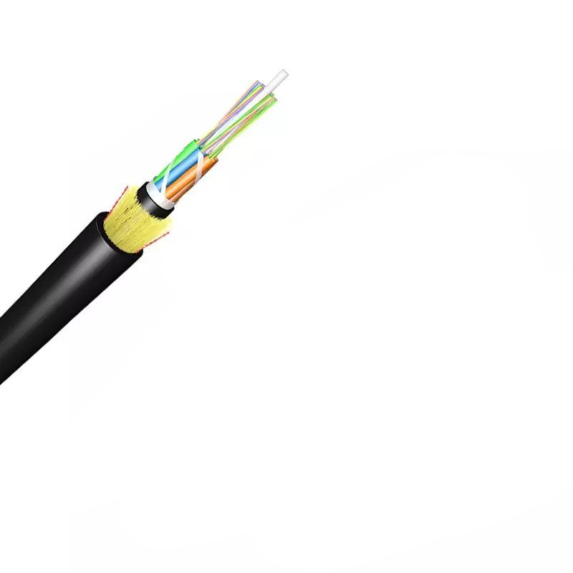
Technical Specification of ADSS Optical Fiber Cable

1. General Information
- Product Type: ADSS (All-Dielectric Self-Supporting) Single Jacket Optical Fiber Cable
- Fiber Mode: Single-Mode (SM)
- Core Fiber Type: G.652.D (compatible with G.655, 50/125μm Multimode, 62.5/125μm Multimode)
- Certifications: ISO9001, ITU-T Rec. G.657A, IEC 60794, ICEA-596, GR-409, YD/T 1997-2009
- Length per Spool: 3km or 4km (2% tolerance allowed)
- Packing: Wooden Spool (Φ1100*750mm), covered by plastic buffer sheet, sealed with strong wooden battens; at least 1m of inside cable end reserved for testing
- MOQ: 100km
- Delivery Time: 5-25 Days
- Port of Loading: NINGBO CHINA
- Payment Term: 30% TT as deposit, 70% Balance before shipping

2. Structural Parameters
Component | Specification
Fiber Optic | UV fiber; G.652.D: @1310nm ≤0.35dB/km, @1550nm ≤0.2dB/km
Tube Filling Compound | Water Blocking & Moisture Proof Thyrotrophic gel
Loose Tube | 1.8-2.0mm PBT; outer diameter options: 1.8mm, 2.0mm, 2.5mm (adjustable: 1.5
Filler | 1.8mm FRP (LDPE/PP)
Central Strength Member | 1.8mm GFRP; diameter options: 2.0mm, 2.5mm, 2.8mm, 3.7mm (adjustable: 1.8
Water Blocking Tape | 0.28mm thickness
Binder | 2 wires Polyester Yarns
Ripcords | 2 wires
Dielectric Strength Members | Aramid Yarns KEVLAR K49-3000D
Inner Jacket | 0.9-1.0mm thickness HDPE/MDPE
Outer Jacket | 1.6-2.0mm thickness HDPE/MDPE; standard thickness 1.8mm (1.5-2.0mm for OEM)
Cable Outer Diameter | 10.7±0.5mm; adjustable (OEM): 8.0
Cable Weight | 85±5kg/km; 75kg/km (12-core), 95kg/km (24-core and larger)

3. Fiber Count & Loose Tube Configuration
- Fiber Count Options: 6, 12, 24, 48, 72, 96, 144, 288 fibers; OEM options:12,24,48,96,120,144 cores
- Loose Tube Configuration:
- 6 fibers: 1x6, 2x6, 4x6
- 8 fibers: 6x8
- 12 fibers: 4x12, 6x12, 8x12, 12x12; OEM design:3+2+1
- 24 fibers:24x12; OEM design:1+4+1 (for 24-core,48-core and others)

4. Optical Characteristics

4.1 Attenuation
Wavelength | Specification
850nm | 50/125μm: ≤3.0dB/km; 62.5/125μm: ≤3.0dB/km
1300nm | 50/125μm: ≤1.0dB/km; 62.5/125μm: ≤1.0dB/km
1310nm | G.652.D: ≤0.36dB/km; G.655: ≤0.40dB/km; G.652.D Normal: ≤0.35dB/km, Best: ≤0.34dB/km; G.657.A1&A2: ≤0.34dB/km
1383nm | G.652.D Normal&Best: ≤0.30dB/km; G.657.A1&A2: ≤0.31dB/km
1490nm | G.652.D Best: ≤0.23dB/km; G.657.A1&A2: ≤0.23dB/km; G.652.D Normal: ≤0.24dB/km
1550nm | G.652.D: ≤0.22dB/km; G.655: ≤0.23dB/km; G.652.D Normal: ≤0.22dB/km, Best: ≤0.21dB/km; G.657.A1&A2: ≤0.20dB/km
1525-1575nm | G.652.D Normal: ≤0.22dB/km, Best: ≤0.21dB/km; G.657.A1&A2: ≤0.21dB/km
1625nm | G.652.D Normal: ≤0.25dB/km, Best: ≤0.24dB/km; G.657.A1&A2: ≤0.22dB/km
1285-1330nm | All fibers: ≤0.37dB/km

4.2 Bandwidth
Wavelength | Specification
850nm | 50/125μm: ≥500MHz·km; 62.5/125μm: ≥200MHz·km
1300nm | 50/125μm: ≥1000MHz·km; 62.5/125μm: ≥600MHz·km

4.3 Mode Field Diameter (MFD)
Wavelength | Specification
1310nm | G.652.D Normal:8.6±0.4μm; G.652.D Best:9.0±0.4μm; G.657.A1:9.0±0.3μm; G.657.A2:8.6±0.4μm
1550nm | G.652.D Normal:9.8±0.5μm; G.652.D Best:10.2±0.4μm; G.657.A1:10.2±0.4μm; G.657.A2:9.6±0.5μm

4.4 Zero Dispersion Wavelength & Dispersion Coefficient
- Zero Dispersion Wavelength:1300-1324nm for all variants
- Dispersion Coefficient (1285-1339nm): G.652.D, G.657.A1&A2: ≤3.4ps/(nm·km)

4.5 Polarization Mode Dispersion (PMD)
- Individual Fiber: G.652.D, G.655: ≤0.20ps/√km; all fiber types: ≤0.1ps/√km
- Design Link Value (M=20, Q=0.01%): G.652.D, G.655: ≤0.10ps/√km; all fiber types: ≤0.06ps/√km

4.6 Bending Loss
Wavelength | Bending Condition | Loss
1550nm | 15mm radius (10 turns) | ≤0.25dB
1550nm | 25mm radius (100 turns) | ≤0.03dB
1550nm | 10mm radius (1 turn) | ≤0.75dB
1550nm | 7.5mm radius (1 turn) | ≤0.2dB
1550nm | 30mm radius (100 turns) | ≤0.05dB
1625nm | 15mm radius (10 turns) | ≤1.0dB
1625nm | 10mm radius (1 turn) | ≤1.5dB
1625nm | 7.5mm radius (1 turn) | ≤0.5dB

4.7 Point Discontinuity
- At 1310nm & 1550nm: ≤0.05dB for all fibers

5. Dimensional Parameters
Parameter | Specification
Cladding Diameter | G.652.D Normal:125±0.7μm; G.652.D Best:125±0.5μm; G.657.A1:125±0.5μm; G.657.A2:125±0.5μm
Core/Cladding Concentricity Error | G.652.D Normal: ≤0.5μm; G.652.D Best: ≤0.4μm; G.657.A1: ≤0.4μm; G.657.A2: ≤0.4μm
Cladding Non-circularity | G.652.D Normal: ≤1.0%; G.652.D Best: ≤0.7%; G.657.A1: ≤0.7%; G.657.A2: ≤0.7%
Coating Diameter | G.652.D Normal&Best:245±5μm; G.657.A1&A2:242±5μm
Coating/Cladding Concentricity Error | G.652.D Normal&Best: ≤12μm; G.657.A1&A2: ≤8μm

6. Mechanical Characteristics
- Fiber Strain: ≥1%
- Fiber Load: ≥9N
- Stress: ≥100kpsi
- Dynamic Stress Corrosion Susceptibility Factor: Unaged & Aged (30 days @85°C, 85% R.H.): ≥20
- Coating Strip Force (Peak Value):1.3-8.9N
- Fiber Curl: ≥4m
- Max. Installation Tension:2400N (for all core configurations)
- Min. Bending Radius: Without Tension:10.0 x Cable Diameter; Under Maximum Tension:20.0 x Cable Diameter

7. Environmental Characteristics
- Temperature Range: Operation: -40°C to +70°C; Installation: -20°C to +60°C; Transport & Storage: -40°C to +70°C
- Dry Heat Aging (30 days @85°C): Attenuation @1310nm &1550nm: ≤0.05dB/km
- Accelerated Aging (30 days @85°C, 85% R.H.): Attenuation @1310nm &1550nm: ≤0.05dB/km
- Temperature Cycling: Attenuation @1310nm &1550nm: ≤0.05dB/km
- Water Soak (30 days @23°C): Attenuation @1310nm &1550nm: ≤0.05dB/km
- Max Span Options:50m,80m,100m,120m,150m (100m span for this model)
- Max Applied Voltage:110kv
- Weather Conditions:25m/s wind speed +0mm Ice Load
- Climate Conditions: No ice formation considered in design

8. Test Requirements
Test Item | Test Method | Acceptance Requirements
Tensile Strength (IEC 794-1-E1) | Apply 5000N load over 50m cable length | Loss change ≤0.1dB at 1550nm; no fiber break, no sheath damage
Crush Test (IEC 60794-1-E3) | Apply 3000N load over 100mm cable for ≥1 minute | Loss change ≤0.1dB at 1550nm; no fiber break, no sheath damage
Impact Test (IEC 60794-1-E4) | 5 impact points, 5 times per point; impact energy 4.5Nm; hammerhead radius 12.5mm; impact rate 2s/cycle | Loss change ≤0.1dB at 1550nm; no fiber break, no sheath damage
Repeated Bending (IEC 60794-1-E6) | Bending diameter 20x OD; 250N load; flexing rate 3s/cycle; 30 cycles | Loss change ≤0.1dB at 1550nm; no fiber break, no sheath damage
Torsion (IEC 60794-1-E7) | 1m length; 150N load; twist rate 1min/cycle; ±90° twist angle; 10 cycles | Loss change ≤0.1dB at 1550nm; no fiber break, no sheath damage
Water Penetration (IEC 60794-1-F5B) | Submerge 3m cable in 1m water for 24 hours | No water leakage from opposite end
Temperature Cycling (IEC 60794-1-F1) | Temperature steps: +20°C→-20°C→+20°C→+40°C; 24h/step; 2 cycles | Loss change ≤0.1dB at 1550nm; no fiber break, no sheath damage
Compound Flow (IEC 60794-1-E14) | 30cm sample; 70°C±2°C; 24 hours | No compound flow
Sheath High Voltage Test | Online test with 9kV voltage (dependent on sheath thickness) | No sheath breakdown

9. Marking & Color Codes

9.1 Sheath Marking
- Content: Fiber cable name, N*cores, G.652D, manufacture year, length (XXXXm); printed every 1 meter
- Color: White
- Note: Occasional unclear length marking permitted if neighboring markings are clear; both cable ends sealed with heat shrinkable end caps
- Custom marking available upon request

9.2 Fiber & Binder Color Code (EIA/TIA 598B)
- Blue
- Orange
- Brown
- Gray
- White
- Red
- Black
- Yellow
- Violet
- Aqua
- Pink
- Green

10. OEM Customization
- Structure Design: Customizable (Tube + Filler + Strength Member)
- Core Count:12,24,48,96,120,144 cores
- Central Strength Member Material: FRP | Steel Wire; Diameter (±0.05mm):1.2mm |1.0mm
- Loose Tube Diameter (±0.05mm):2.1mm |1.8mm
- Filler Material: PP; Diameter (±0.05mm):1.8mm
- Outer Sheath Thickness (±0.1mm):0.8mm (smaller cores),1.6mm/1.9mm (larger cores); Color: Black
- Cable Diameter (±0.2mm):9.0mm (12-core),13mm (24-core and larger)
- Other parameters adjustable as per customer requirements

