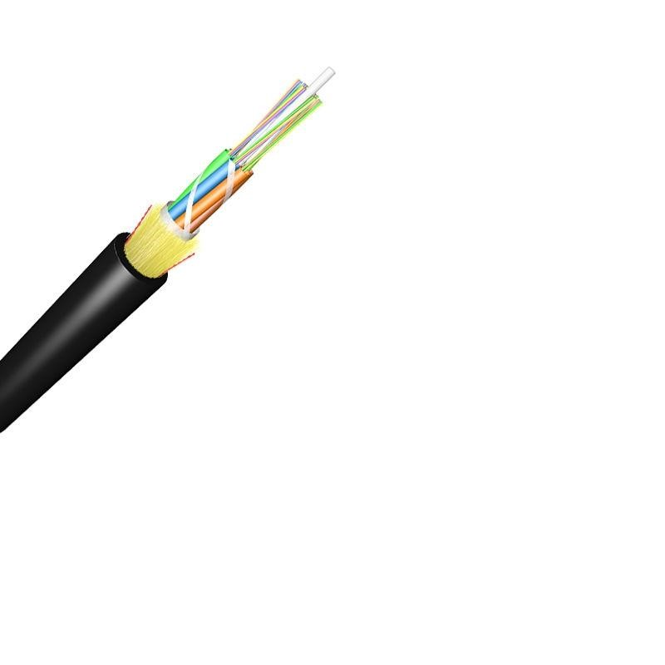
Technical Specification of ADSS Fiber Optical Cable

1. General Information
- Product Type: ADSS Single Jacket Fiber Optical Cable
- Certifications: ISO9001
- Standards: ITU-T Rec. G.657A, IEC 60794, ICEA-596, GR-409, YD/T 1997-2009

2. Fiber Specifications

2.1 Fiber Types
G.652.D/G.655 (single-mode), 50/125μm/62.5/125μm (multimode)

2.2 Key Optical Traits
- Attenuation: ≤0.36dB/km (@1310nm, G.652.D); ≤0.22dB/km (@1550nm, G.652.D); ≤3.0dB/km (multimode @850nm)
- Bandwidth: ≥500MHz·km (50/125μm @850nm); ≥200MHz·km (62.5/125μm @850nm)
- PMD: ≤0.20ps/√km (individual fiber); ≤0.10ps/√km (link design)
- Bending Loss: ≤0.75dB (1550nm, 10mm radius/1 turn); ≤1.5dB (1625nm, 10mm radius/1 turn)

2.3 Dimensions
Cladding diameter: 125±0.7μm (G.652.D Normal); core/cladding concentricity error ≤0.5μm

3. Cable Structure
- Components: GFRP central strength member, PBT loose tube, Aramid yarn reinforcement, HDPE/MDPE sheath
- Fiber Count: 6-288 fibers (OEM: 12-144 cores)
- Dimensions: Diameter 8.0-20.2mm; weight 75-95kg/km (OEM)
- Water Blocking: Water-blocking tape/yarn for moisture resistance

4. Mechanical & Environmental Performance

4.1 Mechanical Traits
- Tensile strength: 5000N (50m cable); min. bending radius: 10×OD (no tension)
- Fiber load ≥9N; strain ≥1%; stress ≥100kpsi

4.2 Environmental Resistance
- Operating temp: -40°C to +70°C; max wind speed 25m/s (0mm ice load)
- Tests (tensile/crush/impact/temp cycling): Loss change ≤0.1dB (@1550nm); no fiber/sheath damage
- Water penetration: No leakage after 24h submersion

5. Key Application & Order Info
- Max Span: 50-150m (110kv max applied voltage)
- MOQ: 100km; Delivery time: 5-25 days; Port: NINGBO CHINA
- Payment Term: 30% TT deposit, 70% balance before shipping
- Customization: Fiber count, structure, marking available per request

6. Packing & Marking
- Packing: Wooden drum (Φ1100×750mm); 3-4km/spool (2% tolerance)
- Marking: Sheath printed every 1m (cable type, fiber count, length); fiber colors per EIA/TIA 598B

