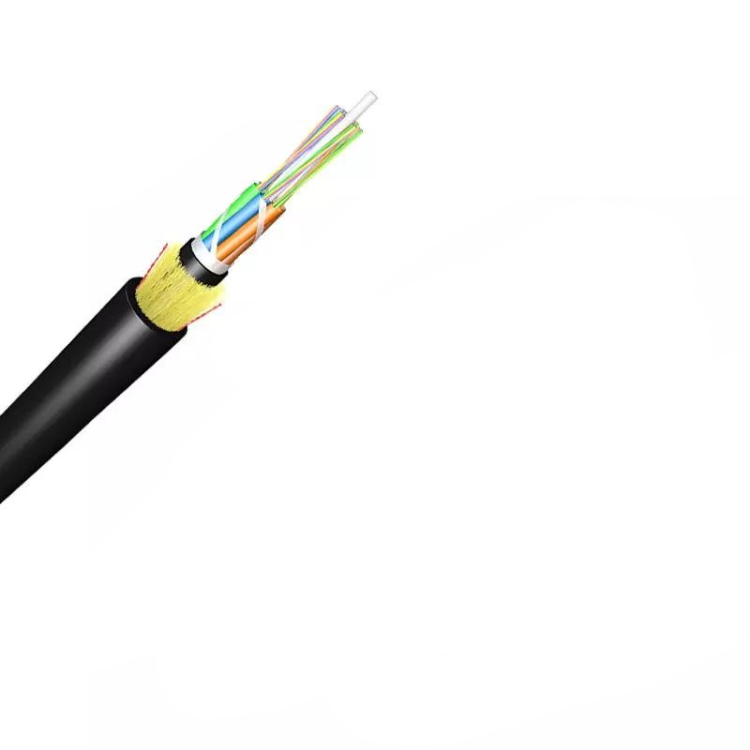
Technical Specification for 12/16/24 Cores G.652.D Optical Fiber Cable (ADSS Type)

1. Product Overview
- Type: All-dielectric self-supporting (ADSS) optical fiber cable with double jacket
- Fiber Type: G.652.D single-mode optical fiber (compliant with ITU-T Rec. G.652D), optional G.655, 50/125μm multimode, 62.5/125μm multimode
- Core Count Options: 12, 16, 24 cores (extended options: 6, 48, 72, 96, 144, 288 cores available on request)
- Sheath Material: PE outer jacket, HDPE/MDPE inner jacket
- Max Span: 200-500m (customizable: 50m, 80m, 100m, 120m, 150m based on climate)
- Max Applied Voltage: 110kv
- Operating Conditions: Wind speed up to 25m/s, 0mm ice load; Operating temperature range: -40°C to +70°C (Installation: -20°C to +60°C; Transport & Storage: -40°C to +70°C)
- Standard Compliance: ITU-T Rec. G.657A, ISO9001, IEC 60794, ICEA-596, GR-409, YD/T 1997-2009

2. Structural Specifications
Component | Details
Optical Fiber | UV fiber G.652.D; Attenuation: @1310nm ≤0.36dB/km, @1550nm ≤0.22dB/km; Coating diameter: 245±5μm
Loose Tube | PBT material, 1.8-2.0mm outer diameter (adjustable: 1.5
Filler | FRP, 1.8mm; Material: LDPE/PP
Central Strength Member | GFRP (Glass Fiber Reinforced Plastic Rod), 1.8mm diameter (standard options: 2.0, 2.5, 2.8, 3.7mm; adjustable for OEM); Optional PE coating
Water Blocking Layer | 0.28mm thick water-blocking tape + water-blocking yarn
Binder | 2 wires polyester yarns
Ripcords | 2 wires
Peripheral Strength Member | Aramid Yarns (KEVLAR K49-3000D)
Inner Jacket | HDPE/MDPE, 0.9-1.0mm thickness
Outer Jacket | HDPE/MDPE, 1.6-2.0mm thickness (standard 1.8mm; 1.5-2.0mm for OEM)
Cable Dimensions | Outer diameter: 10.7±0.5mm (12-core: 9.5
Length per Spool | 3km or 4km (±2% tolerance); Standard drum length: 2000-4000m (single length ≥96% of standard length for ≤10% of total supply)

3. Optical Characteristics
Parameter | Specifications
Attenuation | @850nm (multimode): 50/125μm ≤3.0dB/km, 62.5/125μm ≤3.0dB/km; @1300nm (multimode): 50/125μm ≤1.0dB/km, 62.5/125μm ≤1.0dB/km; @1310nm (G.655): ≤0.40dB/km; @1550nm (G.655): ≤0.23dB/km; @1285-1330nm: All fibers ≤0.37dB/km; @1383nm (G.652.D): ≤0.30dB/km, (G.657.A1/A2): ≤0.31dB/km; @1490nm (G.652.D Best): ≤0.23dB/km, (G.652.D Normal): ≤0.24dB/km, (G.657.A1/A2): ≤0.23dB/km; @1525-1575nm (G.652.D): ≤0.22dB/km (Normal), ≤0.21dB/km (Best); (G.657.A1/A2): ≤0.21dB/km; @1625nm (G.652.D Normal): ≤0.25dB/km, (G.652.D Best): ≤0.24dB/km; (G.657.A1/A2): ≤0.22dB/km
Bandwidth | @850nm: 50/125μm ≥500MHz·km, 62.5/125μm ≥200MHz·km; @1300nm: 50/125μm ≥1000MHz·km, 62.5/125μm ≥600MHz·km
Polarization Mode Dispersion (PMD) | Individual fiber (G.652.D/G.655): ≤0.20ps/√km; Design Link Value (M=20, Q=0.01%): ≤0.10ps/√km
Mode Field Diameter (MFD) | G.657.A2: 125±0.5μm; Cladding non-circularity (G.652.D Normal): ≤0.5μm, (G.657.A2): ≤0.4μm; Coating/cladding concentricity error: As per standard

4. Mechanical Characteristics
- Fiber Strain/Stress: ≥100kpsi (resistance to breakage)
- Dynamic Stress Corrosion Susceptibility Factor: ≥20 (unaged & aged: 30 days @85°C, 85% R.H.)
- Coating Strip Force: 1.3-8.9N (peak value)
- Fiber Curl: ≥4m
- Max Installation Tension: 2400N (all core configurations)
- Min Bending Radius: Without tension: 10×cable diameter; Under max tension: 20×cable diameter

5. Test Requirements
Test Item | Method & Acceptance
Tensile Strength (IEC 794-1-E1) | 5000N load on 50m cable; Loss change ≤0.1dB@1550nm, no fiber break/sheath damage
Crush Test (IEC 60794-1-E3) | 3000N load on 100mm cable for ≥1min; Loss change ≤0.1dB@1550nm, no fiber break/sheath damage
Impact Test (IEC 60794-1-E4) | 5 points×5 impacts, 4.5Nm energy, 12.5mm hammerhead radius, 2s/cycle; Loss change ≤0.1dB@1550nm, no fiber break/sheath damage
Repeated Bending (IEC 60794-1-E6) | 20×OD bending diameter, 250N load, 3s/cycle×30 cycles; Loss change ≤0.1dB@1550nm, no fiber break/sheath damage
Torsion (IEC 60794-1-E7) | 1m length, 150N load, ±90° twist, 1min/cycle×10 cycles; Loss change ≤0.1dB@1550nm, no fiber break/sheath damage
Water Penetration (IEC 60794-1-F5B) | 3m sample submerged in 1m water for 24h; No water leakage from opposite end
Temperature Cycling (IEC 60794-1-F1) | +20°C→-20°C→+20°C→+40°C, 24h/step×2 cycles; Loss change ≤0.1dB@1550nm, no fiber break/sheath damage
Compound Flow (IEC 60794-1-E14) | 30cm sample @70±2°C for 24h; No compound flow
Sheath High Voltage Test | Online test with 9kV (dependent on sheath thickness); No sheath breakdown
Environmental Aging | Dry Heat (30d@85°C): Attenuation change ≤0.05dB/km@1310/1550nm; Accelerated Aging (30d@85°C,85%RH): Same as dry heat; Water Soak (30d@23°C): Same attenuation requirement

6. Marking & Color Coding
- Sheath Marking: Printed every 1m, content: [Cable Type] N*cores G.652D [Manufacture Year] XXXXm; Color: white; Occasional unclear length marking permitted if neighboring markings are clear; Both ends sealed with heat-shrinkable caps
- Fiber/Binder Color Code (EIA/TIA 598B): 1.Blue, 2.Orange, 3.Green, 4.Brown, 5.Gray, 6.White, 7.Red, 8.Black, 9.Yellow, 10.Violet, 11.Pink, 12.Aqua

7. Packaging & Shipping
- Packing: Cable reeled on Φ1100×750mm wooden spools, covered with plastic buffer sheet, sealed with strong wooden battens; ≥1m of inner cable end reserved for testing
- Drum Marking: Manufacturer brand, roll-direction arrow, cable outer end indicator, "FIBER OPTICAL CABLE", "MADE IN CHINA", handling caution plate, contract/project/destination info (if needed); Marking plate includes product name, cable type/size, drum length, gross/net weight, drum number, manufacturing year/month, project/contract number (if needed)
- MOQ: 100km; Delivery Time: 5-25 Days; Port of Loading: NINGBO CHINA; Payment Term: 30% TT deposit, 70% balance before shipping

8. OEM Customization
- Core count: 12,24,48,96,120,144 cores
- Structure design: 3+2+1 (12-core), 1+4+1 (24-core+/others)
- Central strength member: FRP/Steel Wire, 1.0/1.2mm diameter
- Loose tube: 1.8/2.1mm PBT diameter
- Outer sheath thickness: 0.8mm (small cores), 1.6/1.9mm (large cores)
- Cable diameter: 9.0mm (12-core), 13mm (24-core+)
- Custom cable marking available

