Technical Specification for UUTP CAT6 4PR 23AWG PVC CPA Conductor

1. General Information

1.1 Cable Type
U/UTP CAT 6

1.2 Impedance
100 ohm

1.3 Length Options
100m, 305m, 500m, 500ft, 1000ft

1.4 Packing Options
Pull box, wooden spool, carton, pallet

1.5 Minimum Order Quantity (MOQ)
30KM

1.6 Port of Loading
SHANGHAI

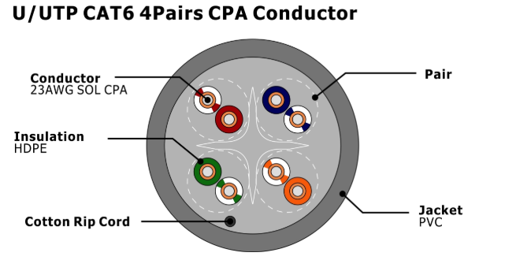
2.1 Conductor
• Material: Solid CPA (Copper Plating Aluminum)
• Size: 23AWG
2.2 Pairs
4 Pairs
2.3 Insulation
• Thickness: 1.02±0.05 mm HDPE
• Material: HDPE
• Colors: Blue-White/Blue, Orange-White/Orange, Green-White/Green, Brown-White/Brown
2.4 Rip Cord
Cotton
2.5 Outer Jacket
• Material: PVC
• Wall Thickness: 0.0157" Nom(0.4mm)
• Outer Diameter (OD): 6.4±0.2mm
3. Standards Compliance
UL 444 & CSA C22.2 No.214 Communications Cables
4. Application Support
• 1000BASE-T, 1000BASE-TX, 100BASE-T, 100BASE-TX, 100VG-AnyLAN, ATM
• VoIP, ISDN, Token, 100MTPPDM, Analog and Data video, POE Type1,2,3,4
5. Electrical Characteristics
Impedance | 1 - 250MHz 100±15 Ohms
Insulation Resistance | ＞5000MΩ*KM
Dielectric strength | DC 2500V 2S
Max.Conductor DC | 10.8 Ohms/100m
Resistance 20℃ | 10.8 Ohms/100m
Res. unbalance (%) | Max. 2.5
Pair to Ground | 330 pF/100m
Capacitance Unbalance | 330 pF/100m
Transfer Impendance | Max 10 mOhms/m @100Mhz
Installation temp. | -30 - 50℃
Operation temp. | -20 - 75℃
7. Physical Properties
Parameter | Specification
Pulling Tension (Max) | 25 lbs(110N)
Bend Radius (Min) | 4 Times the cable diameter
Operating Temperature | -20 to 75 ℃ （ -4 to 167 ℉）

