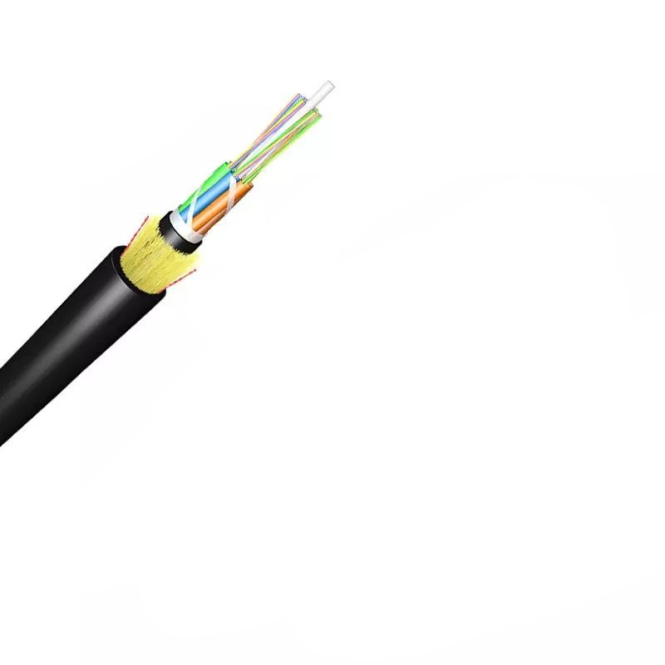
Technical Specification of ADSS Optical Fiber Cable

1. General Information
- Product Type: ADSS (All-Dielectric Self-Supporting) Single Jacket Optical Fiber Cable
- Certifications: ISO9001
- Length per Spool: 3km or 4km (with a tolerance of more than 2%)
- Packing: Wooden Spool (Φ1100*750mm)
- MOQ: 100km
- Delivery Time: 5-25 Days
- Port of Loading: NINGBO CHINA
- Payment Term: 30% TT as deposit, 70% Balance before shipping

2. Key Performance Parameters
- Max Span: 80m (MAT=2100N); Other options include 50m, 100m, 120m, 150m (span needs recalculation based on installation area's climate)
- Max Applied Voltage: 110kv
- Weather Conditions: 25m/s wind speed + 0mm Ice Load
- Temperature Range:
- Operation: -40°C to +70°C
- Installation: -20℃ to +60℃
- Transport & Storage: -40℃ to +70℃
- Cable Outer Diameter: 10.7±0.5mm (adjustable for OEM: 8.0|8.5|9.0|10.5|11.0mm)
- Cable Weight: 85±5kg/km; 75kg/km (12-core), 95kg/km (24-core and larger configurations) (±10.0kg/km tolerance)

3. Construction Details
Component | Specification
Fiber Optic | UV fiber G.652.D; Attenuation: @1310nm ≤0.35dB/km; @1550nm ≤0.2dB/km
Tube Filling Compound | Water Blocking & Moisture Proof Thyrotrophic gel
Loose Tube | 1.8-2.0mm PBT; Outer diameter options: 1.8, 2.0, 2.5mm (adjustable for OEM: 1.5
Filler | 1.8mm LDPE/PP (FRP)
Center Strength Member | 1.8mm GFRP; Diameter options: 2.0, 2.5, 2.8, 3.7mm (adjustable for OEM: 1.8
Water Blocking Tape | 0.28mm thickness
Binder | 2 wires Polyester Yarns
Ripcords | 2 wires
Dielectric Strength Members | Aramid Yarns KEVLAR K49-3000D
Inner Jacket | 0.9-1.0mm thickness HDPE/MDPE
Outer Jacket | 1.6-2.0mm thickness HDPE/MDPE; Standard thickness 1.8mm (1.5-2.0mm for OEM)

4. Fiber Options & Optical Characteristics

4.1 Fiber Types
- Single-mode: G.652.D, G.655
- Multimode: 50/125μm, 62.5/125μm
- Fiber Count Options: 6, 12, 24, 48, 72, 96, 144, 288 fibers; OEM options: 12, 24, 48, 96, 120, 144 cores

4.2 Attenuation
Wavelength | Specification
850nm | 50/125μm: ≤3.0dB/km; 62.5/125μm: ≤3.0dB/km
1300nm | 50/125μm: ≤1.0dB/km; 62.5/125μm: ≤1.0dB/km
1310nm | G.652.D: ≤0.36dB/km; G.655: ≤0.40dB/km; G.652.D Normal: ≤0.35dB/km; G.652.D Best: ≤0.34dB/km; G.657.A1/A2: ≤0.34dB/km
1383nm | G.652.D (Normal/Best): ≤0.30dB/km; G.657.A1/A2: ≤0.31dB/km
1490nm | G.652.D Best: ≤0.23dB/km; G.652.D Normal: ≤0.24dB/km; G.657.A1/A2: ≤0.23dB/km
1550nm | G.652.D: ≤0.22dB/km; G.655: ≤0.23dB/km; G.652.D Best: ≤0.21dB/km; G.657.A1/A2: ≤0.20dB/km
1525-1575nm | G.652.D (Normal/Best): ≤0.22dB/km (Normal), ≤0.21dB/km (Best); G.657.A1/A2: ≤0.21dB/km
1625nm | G.652.D Normal: ≤0.25dB/km; G.652.D Best: ≤0.24dB/km; G.657.A1/A2: ≤0.22dB/km
1285-1330nm | All fibers: ≤0.37dB/km

4.3 Bandwidth
- 850nm: 50/125μm ≥500MHz·km; 62.5/125μm ≥200MHz·km
- 1300nm: 50/125μm ≥1000MHz·km; 62.5/125μm ≥600MHz·km

4.4 Polarization Mode Dispersion (PMD)
- Individual fiber: G.652.D/G.655 ≤0.20ps/√km; All fiber types ≤0.1ps/√km
- Design Link Value (M=20, Q=0.01%): G.652.D/G.655 ≤0.10ps/√km; All fiber types ≤0.06ps/√km

4.5 Mode Field Diameter (MFD)
Wavelength | Specification
1310nm | G.652.D Normal: 8.6±0.4μm; G.652.D Best:9.0±0.4μm; G.657.A1:9.0±0.3μm; G.657.A2:8.6±0.4μm
1550nm | G.652.D Normal:9.8±0.5μm; G.652.D Best:10.2±0.4μm; G.657.A1:10.2±0.4μm; G.657.A2:9.6±0.5μm

4.6 Zero Dispersion Wavelength & Dispersion Coefficient
- Zero Dispersion Wavelength: 1300-1324nm (all variants)
- Dispersion Coefficient (1285-1339nm): G.652.D, G.657.A1/A2 ≤3.4ps/(nm·km)

4.7 Bending Loss
- 1550nm: 10 turns (15mm radius) ≤0.25dB; 100 turns (25mm radius) ≤0.03dB; 1 turn (10mm radius) ≤0.75dB; 1 turn (7.5mm radius) ≤0.2dB; 100 turns (30mm radius) ≤0.05dB
- 1625nm: 10 turns (15mm radius) ≤1.0dB; 1 turn (10mm radius) ≤1.5dB; 1 turn (7.5mm radius) ≤0.5dB

4.8 Point Discontinuity
- 1310nm & 1550nm: ≤0.05dB (all fibers)

5. Dimensions
Parameter | Specification
Cladding Diameter | G.652.D Normal:125±0.7μm; G.652.D Best/G.657.A1/A2:125±0.5μm
Core/Cladding Concentricity Error | G.652.D Normal: ≤0.5μm; G.652.D Best/G.657.A1/A2: ≤0.4μm
Cladding Non-circularity | G.652.D Normal: ≤1.0%; G.652.D Best/G.657.A1/A2: ≤0.7%
Coating Diameter | G.652.D (Normal/Best):245±5μm; G.657.A1/A2:242±5μm
Coating/Cladding Concentricity Error | G.652.D (Normal/Best): ≤12μm; G.657.A1/A2: ≤8μm

6. Mechanical Characteristics
- Fiber Strain: ≥1%
- Fiber Load: ≥9N
- Stress: ≥100kpsi
- Dynamic Stress Corrosion Susceptibility Factor: ≥20 (unaged & aged: 30 days @85°C, 85% R.H.)
- Coating Strip Force (Peak Value): 1.3-8.9N
- Fiber Curl: ≥4m
- Max. Installation Tension: 2400N (all core configurations)
- Min. Bending Radius: Without Tension - 10.0×Cable Diameter; Under Maximum Tension - 20.0×Cable Diameter

7. Environmental Characteristics
Test Condition | Attenuation Requirement (1310nm/1550nm)
Dry Heat Aging (30 days @85°C) | ≤0.05dB/km / ≤0.05dB/km
Accelerated Aging (30 days @85°C, 85% R.H.) | ≤0.05dB/km / ≤0.05dB/km
Temperature Cycling | ≤0.05dB/km / ≤0.05dB/km
Water Soak (30 days @23°C) | ≤0.05dB/km / ≤0.05dB/km

8. Test Standards & Acceptance Criteria
Test Item | Test Method | Acceptance Requirements
Tensile Strength | IEC 794-1-E1; 5000N load over 50m cable | Loss change ≤0.1dB (1550nm); No fiber break/sheath damage
Crush Test | IEC 60794-1-E3; 3000N load over 100mm cable (≥1min) | Loss change ≤0.1dB (1550nm); No fiber break/sheath damage
Impact Test | IEC 60794-1-E4; 5 points×5 times; 4.5Nm energy; 12.5mm hammerhead radius; 2s/cycle | Loss change ≤0.1dB (1550nm); No fiber break/sheath damage
Repeated Bending | IEC 60794-1-E6; 20×OD bending diameter; 250N load; 3s/cycle×30 cycles | Loss change ≤0.1dB (1550nm); No fiber break/sheath damage
Torsion | IEC 60794-1-E7; 1m length; 150N load; ±90° twist; 1min/cycle×10 cycles | Loss change ≤0.1dB (1550nm); No fiber break/sheath damage
Water Penetration | IEC 60794-1-F5B; 3m sample submerged in 1m water for 24h | No water leakage
Temperature Cycling | IEC 60794-1-F1; +20→-20→+20→+40°C; 24h/step×2 cycles | Loss change ≤0.1dB (1550nm); No fiber break/sheath damage
Compound Flow | IEC 60794-1-E14; 30cm sample @70±2°C for 24h | No compound flow
Sheath High Voltage Test | Online test (9kV, dependent on sheath thickness) | No sheath breakdown

9. Marking & Color Code

9.1 Sheath Marking
- Content: [Cable type] [N*cores] G.652D [Manufacture year] [XXXXm]
- Print Interval: Every 1 meter
- Color: White
- Notes: Occasional unclear length marking permitted if neighboring markings are clear; Cable ends sealed with heat shrinkable caps

9.2 Fiber & Binder Color Code (EIA/TIA 598B)
- Fiber Colors: Blue (NO.1), Orange (NO.2), Green (NO.3), Brown (NO.4), Gray (NO.5), White (NO.6), Red (NO.7), Black (NO.8), Yellow (NO.9), Violet (NO.10), Pink (NO.11), Aqua (NO.12)

10. OEM Customization
- Core Count: 12,24,48,96,120,144 cores
- Design: 3+2+1 (12-core); 1+4+1 (24-core,48-core, etc.)
- Material Options: Central Strength Member (FRP/Steel Wire); Loose Tube (PBT); Filler (PP); Outer Sheath (HDPE)
- Adjustable Parameters: Jacket thickness, cable diameter, length per spool, marking content

11. Compliance Standards
ITU-T Rec. G.657A, ISO9001, IEC 60794, ICEA-596, GR-409, YD/T 1997-2009, EIA/TIA 598B

